Eyes Up, Marin
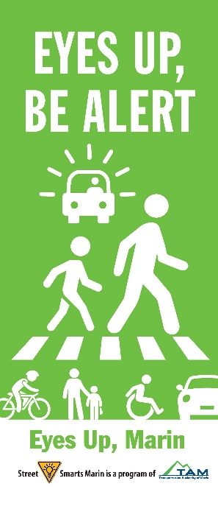
Let’s Make our Streets Safer for Everyone!
From April 11 through the end of May, you will again see bright and colorful banners and lawn signs popping up all over Marin asking people to keep their “Eyes Up” and be alert. These signs will be asking drivers to slow down, watch when turning and look for pedestrians in the crosswalk; bicyclists to yield to pedestrians and to follow the rules of the road; And those walking to pay attention when crossing the street.
These messages will also show up in your social media feeds, and you can find them at www.streetsmartsmarin.org. Please share with your friends, family and co-workers!
To get a free lawn sign for your yard, contact your local municipality. There is a tab on the www.streetsmartsmarin.org website that has this information.
The Eyes Up, Marin campaign is part of the Street Smarts Program and Safe Routes to Schools, locally funded programs of the Transportation Authority of Marin. This traffic safety campaign educates drivers, pedestrians and cyclists about safety issues, including distracted driving. The goal is to encourage people to adopt and practice attitudes and behaviors that will reduce the number of traffic-related accidents and make our streets safer for everyone.
The program focuses on placing outdoor messaging at “hotspots” throughout Marin County – bold reminders at the locations where traffic problems occur most frequently. The message placement was determined based on findings from the 2018 Marin County Travel Safety Plan as well as analysis of 2016-2020 countywide collision data from the Statewide Integrated Traffic Records System.
Our countywide partners including school districts, jurisdictions, emergency service providers, and community organizations will be sharing the new campaign images and safety messages widely. Please join this important effort to make our streets safer for all! www.streetsmartsmarin.org.

Eyes Up, Marin
Let’s Make our Streets Safer for Everyone!
From mid-October through the end of November, you’ll see bright and colorful banners and lawn signs popping up all over Marin asking people to keep their “Eyes Up” and be alert. These signs will be asking drivers to slow down, watch when turning and look for pedestrians in the crosswalk; bicyclists to yield to pedestrians and to follow the rules of the road; And those walking to pay attention when crossing the street.
These messages will also show up in your social media feeds, and you can find them at www.streetsmartmarin.org. Please share with your friends, family and co-workers!
The Eyes Up, Marin Campaign is part of the Street Smarts Program and Safe Routes to Schools, locally funded programs of the Transportation Authority of Marin.

