Eyes Up, Marin
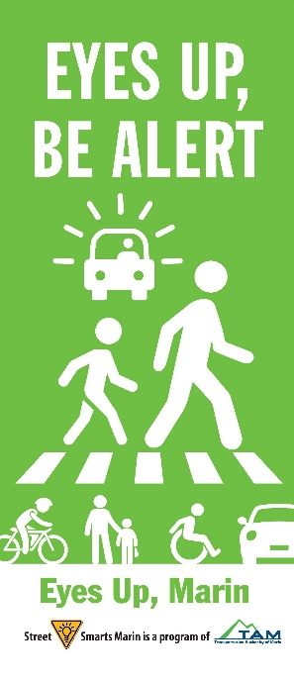
Let’s Make our Streets Safer for Everyone!
From April 11 through the end of May, you will again see bright and colorful banners and lawn signs popping up all over Marin asking people to keep their “Eyes Up” and be alert. These signs will be asking drivers to slow down, watch when turning and look for pedestrians in the crosswalk; bicyclists to yield to pedestrians and to follow the rules of the road; And those walking to pay attention when crossing the street.
These messages will also show up in your social media feeds, and you can find them at www.streetsmartsmarin.org. Please share with your friends, family and co-workers!
To get a free lawn sign for your yard, contact your local municipality. There is a tab on the www.streetsmartsmarin.org website that has this information.
The Eyes Up, Marin Campaign is part of the Street Smarts Program and Safe Routes to Schools, locally funded programs of the Transportation Authority of Marin.

